/*FULL STACK APPLICATION FLOW DIAGRAM*/
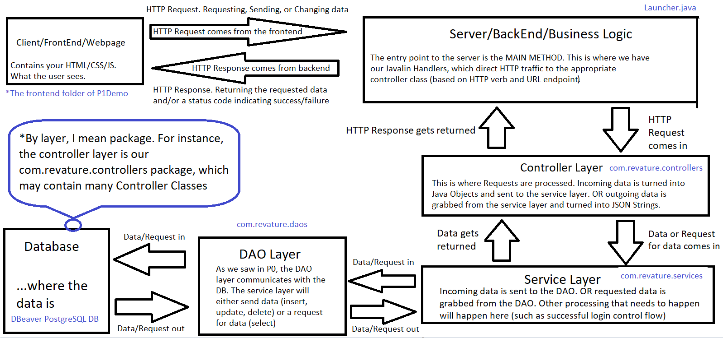

What is Postman again?

- Postman is a service that lets us make HTTP requests to a backend server.
  - We’ll be using it to test our java servers (to make sure the appropriate data and status codes get returned)
  - It will be VERY helpful for us because we can test whether our Java servers work before building up a front end.
    - Something goes wrong while making a request from the front end? Pop that same request into postman. If it works, the problem is likely on the front end. If it fails, the problem is likely on the backend.
REST

- Stands for REpresentational State Transfer.
- REST is an architectural style/convention for web services that represents a server (backend) as a collection of resources that can be accessed by specific endpoints. (so it’s just an architectural style, right? it lays out guidelines that we CHOOSE to follow. It’s not a language or even a design pattern)
  - Endpoints are determined by URI. (Remember, URIs identify a single resource)
  - In a nutshell, REST outlines how a client and server communicate over the web.
- REST was designed by Roy Fielding in his dissertation in 2000.
  - Roy Fielding claims that REST is not limited to HTTP as its protocol… others strongly debate that.
  - This dude is one of the uncs of the internet. He was involved in a lot of stuff.

- There are 6 guiding principles/constraints of a RESTful API:

  - Client-server Architecture
    - Separates user interface (front end) from data storage (your database, manipulated by back end code), allowing for portability across multiple platforms and abstraction in general.
  - Layered Server Architecture
    - The server should be designed in a layered fashion so that the client is not aware of how the server is designed beyond the layer that interacts directly with requests.
  - Stateless
    - Each request from the client to the server must contain all information necessary for the server to understand and complete the request. The server does not store any context (session) information about the client.
      - What this means is that HTTP Requests have no knowledge of past or future requests. Data is NOT stored in the server. The server gathers data from the database only.
      - In a fully RESTful api, you won’t use session storage. But you guys are allowed to. REST is a GUIDELINE not a law.
  - Cacheable
    - Our responses should be able to be saved by the client. Because responses are resources at particular endpoints, those resources should be cacheable (saveable) so we can reduce repeat requests to the server.

  - Uniform Interface
    - The system architecture (specifically our endpoints) should be designed in a way that makes finding resources highly logical. URIs should proceed from the general to the collective to the specific resources. For example:
    - www.mycars.com/cars - Returns a resource that is all the cars in the database.
    - www.mycars.com/cars/sportcars - Return all cars that are sportscars in the database
    - www.mycars.com/cars/sportcars/1 - Returns a single car that is the first sportscar in the database.
  - (Optional) Code on demand
    - This allows client functionality to be expanded by downloading and executing code in the form of applets or scripts to use with the resources. This is not particularly well defined or agreed upon by the software development community at large.

- These 6 principles are technically all optional. The RESTful philosophy is just that - a philosophy. You can build a perfectly functional server without paying attention to REST. It’s just that it makes our lives way easier to follow a tried and true architectural style.

- REST requires the use of HTTP verbs/methods. Here’s a refresher:
  - GET - This is simply used to request information. Generally it will have an empty body.
    - Analogous to a select statement in SQL.
  - POST - This is used to create a new object/add completely new information. This information should be contained in the body.
    - Analogous to insert statements in SQL.
  - PUT - Used to update a complete resource. Information should be in the body.
    - Analogous to Update.
    - PUT will update every column the row has. Update an entire row.
  - PATCH - Used to update a specific part of a resource. I.e. updating a single field for an object, not all of the object.
    - Analogous to update table set column1, column2, column(n).
    - PATCH will update only specific columns
  - DELETE - Removes the resource.
    - Analogous to delete.
  - HEAD - just returns the header of the request.
    - Remember, the header has stuff like cookies and other metadata
  - TRACE - Traces the path the request takes on its way to the server.

- So, what exactly is a REST “Resource”?
  - A REST resource is a very broad term. Any information or functionality can be considered a resource: a document, an image, a collection of other resources, a Java object, or even a method invocation.
    - HTTP Requests are sent to certain endpoints in the backend that allow access to certain resources.
    - Resources are not views. They’re data and functionality accessible to the user. Displaying the resource is the responsibility of the client. This is typically a webpage, etc., that the user sees - hence “view”.
  - A REST resource gets “exposed” on the backend, and can be accessed with a request to its specific address
    - So mycars.com/cars/sportcars/3 exposes the 3rd sportscar specifically.

  - The state of the resource at any time is the “resource representation.” It consists of the data, the metadata describing the data, and hypermedia links which can help the client transition to more related information.

- Putting it all together: Javalin is how we establish an endpoint for resources to live at. Javalin provides the structure to allow us to build a RESTful api. Since Javalin lets us expose REST api endpoints, making HTTP calls to these endpoints let a user consume these endpoints

Java Sessions & Cookies

- HTTP is stateless, which means that each new request from the client to the server has no memory of previous requests that were sent.

- A classic (albeit now kinda old) way to resolve this issue is by tracking client request history/information in a Session. Sessions are stateful and can temporarily store data about the user. When a Session is created, a cookie is added to the response returned to the client. It can then be sent back with future requests to identify the user on the client side.
  - A cookie is a small piece of data that is sent from the server and stored on the front end.
  - We will be auto-generating cookies with the HTTPSession interface before getting into more modern stuff.
- Sessions can store information about our users in key value pairs. This information is kept on the server, not the client. This is how we can do things like determine a logged in user’s role, or their id.
  - We can use the setAttribute(“key”, “value”) method to set a value to a particular key.
  - We can use the getAttribute(“key”) method to get the value of a particular key.

- Richardson Maturity Model:
  - Defines how “RESTful” the api is
  - Level 0: No intentional RESTful Traits. The api is Remote Procedural Calls which executes code instead of giving resources. Any HTTP verb is used for any action.
  - Level 1: The API is now structured as a collection of resources but little concern is given to HTTP verbs.
  - Level 2: HTTP verbs are used in their correct RESTful contexts. Also appropriate status codes are used.
  - Level 3: Hypermedia Controls - HATEOAS (Hypermedia As The Engine Of Application State.)
    - Information about how to better use the API is included in every response. Often by using very descriptive status codes everywhere.
    - This should work across changes to the server.
    - HATEOAS builds a client-server relationship where the client continues to learn more about the server’s resources with every response.
      - This is the point of hypermedia links!!
      - We know that sportscar #3 can be found here: www.mycars.com/cars/sportcars/3
      - The client learns that sportscar 3 is located within the collective resource sportcars, within the collective resource cars.
        - We would also include a relevant status code to let the user know they made a completely valid request, or not.

Design Pattern talk below---------------------------------------------------------

*Not on curriculum but this should be a good look into why we structure things the way we do.

Model-View-Controller (MVC) Design Pattern (front end design pattern)

- The MVC design pattern pertains to how we display content/data to the user.

- Models: This is our data/information, generally represented as objects. (This tends to be based on the Classes in our models package)
- Views: This is what the client sees/what content gets displayed. This is an HTML page. (with CSS styling, JS functionality, etc.). Eventually Angular.
  - This typically involves a webpage that sends requests and takes responses from the server, and changes the webpage accordingly.
- Controllers: This is the logic that is used to construct the view based on the models. The Classes in our controllers layer is responsible for getting the appropriate HTTP response data and sending it back to the client, thus changing the User’s view (usually).

Front Controller Design Pattern

- Front controllers provide a single entry point for incoming requests to an application, and then delegate the requests to the appropriate Handlers, typically found in the Controller classes.
  - You can think of it like a main entrance for all HTTP Requests, which send sends each Request where they need to go
- This is what we’re doing in our main method with Javalin when we expose RESTful endpoints
  - E.g. app.get(“/loans”, <some Handler in the Controllers>);
  - So any GET requests ending in /loans will get picked up by this handler, and probably do something like return a list of all loans from the DB.
- Benefits:
  - Provides a centralized avenue for all requests which helps for user activity tracking, security, and cleaner code.

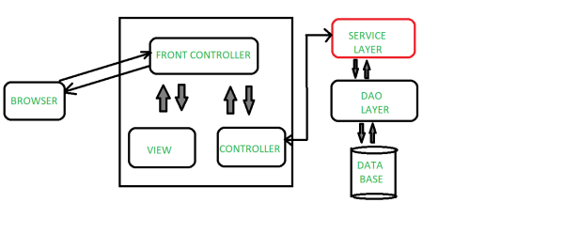

Java Layered Architecture

- Projects should conform to the following 3 layered architecture for Java applications:
- src/main/java contains your actual application. Each package in src/main/java tends to hold a layer:
  - 1st layer (web/presentation layer) - This layer should contain your Javalin/Controllers/whatever connects/communicates with your front end. This typically consists of your main method (with javalin endpoints) and the controller layer.
  - 2nd layer (services/business layer) - This is where business logic of your application should take place. (i.e. validation of username/password) before allowing the DAOs to read/write to the database, or send data back to the client.
  - 3rd layer (repository/DAO/persistence layer) - This is where your Data Access Objects (DAOs) live. These are the Java objects that connect to and retrieve or send information to the database.

- Outside these three layers you may have additional packages for models, or utils, etc.
- There are also other folders that contain logic to supplement your application
  - src/main/resources - contains non-Java files your application needs in order to run. We’ll see this more later.
  - src/test/java - this is where your test classes live

